Mercy College

Year Eight Science
Slime Mould Investigation

What are Slime Moulds?
Slime moulds are a group of small encrusting moulds consisting of over 500 species. Slime moulds are normally found in cool shady moist places on rotting logs, leaf litter or moist organic soils. They can grow to a few 100 millimetres in size and are often brightly coloured. They feed on bacteria, decaying/rotting organic matter and other microscopic organic material.

The group has in the past been regarded as “of uncertain origin” and also classified as both a fungus and an animal. It is now considered as a member of the Kingdom Protista.

Its life cycle starts as a spore cell (like a fungus), which can be distributed widely by air and water, and this develops into a .single celled multinucleate plasmodium (or large bag of cytoplasm). This stage can travel by a process of protoplasmic streaming towards food sources, which it then engulfs and consumes. The rate of movement/growth can be as much as 30mm/hour. The plasmodium grows best in moist areas with temperatures below 25C. If environmental conditions deteriorate (too cold, hot, or dry) they will move into an irreversible spore-forming reproductive stage.

This investigation will use the slime mould Physarum polycephalum, as it easy to grow on agar plates. It is harmless to humans; but the specimen and agar should not be touched as this will introduce other microbes to the agar medium and possibly ruin the experiment. Oat flakes (think porridge) have been used as the basic food source to grow the specimens. Remarkably the slime can “sense” where the food is and move towards it (like an animal).

Instructions for the Investigation

The aim of the investigation is to determine what factors affect the growth of the mould. Food types, food quantity, distance of food from the initial specimen, and light intensity may all affect the speed and strength of growth. Note: The agar provides constant moisture conditions and varying the temperature is likely to result in the specimen stopping any further growth.

In bench groups (of 3-4 students) plan what is to be tested (rate of growth, type of food etc) and complete the Planning Section. Each student will then get a sample of slime mould growing on an agar plate in a Petri dish. Depending on what they are testing they can also get different types of food. Measurements should then be taken over a couple of days to record the growth rate and observe the directions etc. Specimens can be taken home to record the growth over a period of several hours. Measurements should be taken to the nearest ½ mm with a clear ruler.

Data should be collected in tabular form and can then be processed and displayed on graphs or using Excel spreadsheet charts. Evaluations can then be completed onto a final copy sheet for assessment. The Planning process is a group activity, but the Conducting of the experiment (all measurements) and Processing (plotting) should be individual work. In evaluating the investigation you can refer to the results of other group members to compare and contrast growth. A final copy of the investigation can then be written-up for handing in and assessment.
Slime Moulds

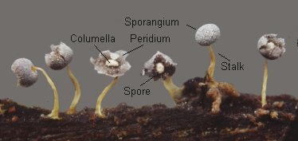

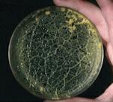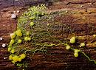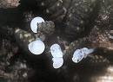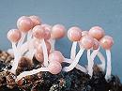

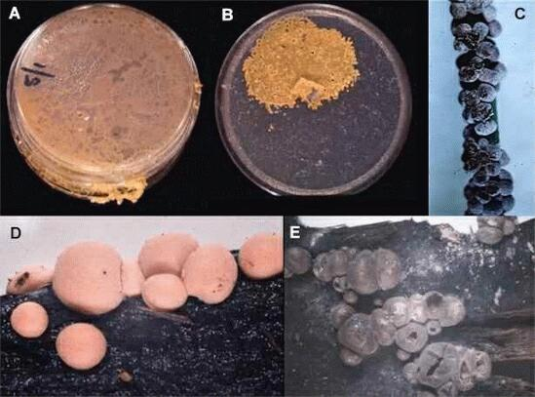
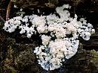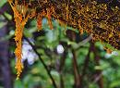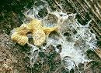

MERCY COLLEGE
SCIENCE INVESTIGATION

TITLE OF INVESTIGATION: _____________________________________________

STUDENT NAME: _______________________ DATE COMPLETED: ____________

OTHER GROUP MEMBERS: _________________________________________________________

marks out of 6 | Planning Investigations | Conducting Investigations  (Doing my Investigation) | Processing Data  (Analysing my results) | Evaluating investigations  (Assessing my design)
2 | □ I can say which things I  would change or  measure | □ I use pictures and write  words to say what  happened. | □ I can say what else  changed when we  changed things. | □ I can say if what  happened was what I  predicted.
3 | □ I can say how I will  make it a fair test.  □ I can predict what might  happen based on personal  experience. | □ I can use simple  equipment consistently.  □ I can record my results in  simple tables, diagrams  or as written  observations. | □ I can display my results  in a table or bar graph.  □ I can recognize and  describe trends in the  results but I cannot give  the reason for them. | □ I can identify the  differences we had in  doing the investigation  well.
4 | □ I can identify the thing I  will change and the thing  I will measure.  □ I can identify at least one  thing that I must keep the  same. | □ I take care to make sure  that my measurements  are accurate and use the  correct units.  □ I make several repeat  measurements for each  test. | □ I calculate averages  from repeated trials. I  use line graphs  whenever appropriate.  □ I can describe the  trends in the results and  can say why they are  like that. | □ I can give some general  suggestions for how to  improve the  investigation.
5 | □ I can analyse a problem  and write my own  question or hypothesis.  □ I can identify most of the  things that I must keep  the same. | □ I can choose suitable  equipment on my own.  □ I use a practice run to  try and improve the  procedure and/or the  method of taking  measurements. | □ As for Level 4.  □ My explanations for the  trends in the results are  reasonably correct  scientifically. | □ I can make specific  suggestions as to how to  improve the design or  how to make  measurements more  accurately.
6 | □ I use my science  knowledge to justify any  predictions that I make.  □ I plan for making  accurate measurements | □ I select equipment and  instruments that will  make my observations or  measurements even more  accurate. | □ I select the graph type  and scales that displays  the data effectively.  □ My conclusions are  consistent with the  results, and I explain  the results in terms of  scientific knowledge  and relate to the  question or hypothesis. | □ I can recognize  inconsistencies in the  results, identify some of  the important sources of  error and explain how  they can be reduced.

Comment: ______________________________________________________________________
___________________________________________________________________________________________________________________________________________________________________

Planning
1. List all the variables that could affect your investigation.
L2
(You can attach evidence of brainstorming or research on the back of this worksheet.)
………………………………………………………………………………………………………………………………………………………………………………………………………………………………………………………………………………………………………
2. Which variable will you be testing?
L2
…………………………………………………………………………………………………
3. Which variables will you keep the same?
…………………………………………………………………………………………………
L3
…………………………………………………………………………………………………
4. What is the Independent variable? (The variable that is deliberately changed to see its effect) ……………………………………………………
L4
(Explain how you plan to change this variable)………………………………………………
…………………………………………………………………………………………………
5. What is the Dependent Variable? (The variable that you expect will change because the independent variable was changed) ……………………………………………………
L4
(Explain how you will plan to find out whether this variable has changed)…………………
……………………………………………………………………………………………….
6. Which variables do you need to control (or keep the same) to make this a fair test. How do you plan to do this?
L5
………………………………………………………………………………………………………………………………………………………………………………………………………………………………………………………………………………………………………
7. Hypothesis/prediction: (what do you think is going to happen?)
Write an “If… then…” statement …………………………....………………………………
L5
…………………………………………………………………………………………………
Why do you think this is going to happen? (Explain the reasoning behind your Hypothesis.) ............................................................................………………………………………………
L3
L5
L6
…………………………………………………………………………………………………
............................................................................………………………………………………
…………………………………………………………………………………………………

Conducting

1. What equipment will you need? Make a list
……………………………………………………………………………………………………………………………………………………………………………………………………
L2
2. How will you use this equipment safely? Check with your teacher that your plan is safe.
……………………………………………………………………………………………………………………………………………………………………………………………………
L3
L4
…………………………………………………………………………………………………
3. Draw a scientific diagram and explain how you will use the equipment shown to carry out your investigation – this should be in enough detail for someone to follow.
L3
L4
L5
L6
Your explanation should clearly show that you have thought about how to improve safety and accuracy.

Diagram | Method (point form)
………………………………………………….
………………………………………………….
………………………………………………….
………………………………………………….
………………………………………………….
………………………………………………….
………………………………………………….
………………………………………………….
………………………………………………….
………………………………………………….
………………………………………………….
………………………………………………….
………………………………………………….

4. What happened? Describe your observations and record your results (including results from a trial run if you did one).
(What is the best way to record your results…a table? Written description? Diagram?)
L2
L3
L4
L5

Processing Data

1. Display your results so they can be easily interpreted.
(What is the best way to display your results…a bar or column graph? a histogram?
a line graph?)
L3
L4
L5
L6

2. Did you use calculations (e.g. averages) to help you process your data? Describe them or show your working.
L4
………………………………………………………………………………………………………………………………………………………………………………………………………………………………………………………………………………………………………………
3. Describe your graph. What pattern or trend does it show?
…………………………………………………………………………………………………
L3
…………………………………………………………………………………………………
…………………………………………………………………………………………………
4. Conclusion: What can you conclude from your data? When writing your conclusion it is
important to:
L4
L5
L6
- state whether your results support your hypothesis or prediction
- try to explain what happened using science ideas
…………………………………………………………………………………………………………………………………………………………………………………………………………………………………………………………………………………………………………………………………………………………………………………………………………

Evaluating Investigations

1. Make a general comment on how the investigation went.
…………………………………………………………………………………………………
L2
…………………………………………………………………………………………………
2. What difficulties or problems did you have when doing this investigation?
…………………………………………………………………………………………………
L3

…………………………………………………………………………………………………
……………………………………………………………………………………………………………………………………………………………………………………………………

3. How could you improve this investigation?
(Think about: - what was the purpose and was this the best way of achieving it?
L4
L5
- how could you improve the accuracy of measurements or results?
- how might you make this investigation more fair?
- how you would do it differently if you could do it again.

…………………………………………………………………………………………………………………………………………………………………………………………………………………………………………………………………………………………………………………………………………………………………………………………………………………………….…………………………………………………………………………………………………………………………………………………………………………………………………………………………………………………………………………………………………………………………………………………………………………………………………………

4. What were some of the important sources of error that could have caused inconsistencies in your results? Explain how they could be reduced.
…………………………………………………………………………………………………………………………………………………………………………………………………………………………………………………………………………………………………………………………………………………………………………………………………………………………………………………………………………………………………………………………………………………………………………………………………………………………………………………………………………………………………………………………………………………………………………………………………………………………………………
L6
K Grey 270503

